Project Design Phase

Problem - Solution Fit Template
Project Title | DarshanEase: A Smart Temple Darshan Booking System Using MERN Stack
Team ID | ALITS-CSD-2026-DarshanEase
Team Members | Salapala Tharun Kumar Reddy (Team Leader); A. Goutham; M. Siva Prasad; M. Akhila; K. Hemalatha
College | Anantha Lakshmi Institute of Technology and Sciences (ALITS)
Academic Year | 2026

Customer segment
Devotees travelling to temples for darshan (domestic pilgrims, working professionals, families, elderly visitors) and temple administration staff managing bookings.
Problem
- No single platform to check darshan slot availability and book in advance.
- Travel planning (bus/train/flight) is disconnected from temple booking.
- Long, unpredictable physical queues at temple entry.
Trigger to act
An upcoming festival, holiday, or personal occasion prompts the devotee to plan a temple visit, but the lack of visibility into slot availability and travel options creates friction and uncertainty.
Emotional response
Anxiety about wasted travel time, frustration with fragmented booking channels, and relief once a confirmed slot and journey plan are in hand.
Existing alternatives
- Calling the temple helpline directly.
- Walking in and queuing without a booking.
- Using separate, unlinked apps for travel and no app at all for temple booking.
Solution (DarshanEase)
A centralized MERN-based web application where a devotee registers once, browses temples, books a darshan slot with instant confirmation, tracks booking history, and plans onward travel — all from a single responsive interface, while admins manage slots and bookings through a dedicated dashboard.
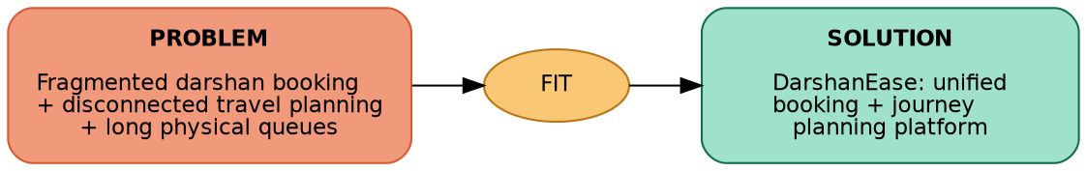
Figure: Problem-solution fit for DarshanEase
Why this is a fit
- Directly removes the fragmentation devotees experience today between booking and travel planning.
- Reduces physical queuing by moving slot allocation online.
- Gives temple administration real-time visibility and control over bookings.

